228X1A1220(KHIT)
Chandana & Team
PROJECT DOCUMENTATION
Title: iRevolution: A Data-Driven Exploration of Apple’s iPhone Impact in India Using Tableau
Introduction
In the present digital era, smartphones have become an essential part of daily life. Among various smartphone brands, Apple’s iPhone holds a strong global reputation as a premium and innovative product. India is one of the fastest-growing smartphone markets in the world, making it important to understand how Apsple’s iPhone has influenced the Indian market.
This project focuses on analyzing and visualizing the impact of Apple’s iPhone in India using Tableau. By examining sales trends, regional performance, demographic distribution, and social media sentiment, this project aims to provide meaningful and data-driven insights. The objective is to transform raw data into visual analytics that support better decision-making for businesses and stakeholders.
Problem Definition and Understanding
The Indian smartphone market is highly competitive, with multiple brands offering products at different price ranges. Although Apple has a strong brand image globally, its growth and penetration in India depend on various factors such as pricing strategy, customer preferences, competition, and digital influence.
Organizations require accurate insights to understand where iPhone sales are increasing, which regions contribute most to revenue, and which customer segments are driving growth. Without proper data analysis and visualization, it becomes difficult to identify trends and patterns from large volumes of data.
Therefore, there is a need for a structured data analytics system that can collect, process, analyze, and visualize iPhone-related data in an effective way. This project addresses that need by using Tableau to create interactive dashboards and reports.

Business Requirements
The primary business requirement of this project is to analyze iPhone sales performance across different regions of India and identify growth patterns over time. The project also aims to examine demographic characteristics such as age groups, income levels, and geographic distribution of iPhone users.
Another important requirement is to analyze market share and compare it with competitors in the Indian smartphone industry. In addition, understanding customer sentiment through social media analysis helps in evaluating brand perception and cultural influence.
The final requirement is to present all findings through interactive dashboards and stories that allow stakeholders to filter and explore data dynamically.
Social and Business Impact
This project has significant business value as it supports data-driven decision-making. It helps Apple and other stakeholders understand market behavior and consumer trends. The insights derived from the analysis can guide marketing strategies, pricing decisions, and regional targeting.
From a social perspective, the project reflects how technology adoption influences lifestyle and aspirations in India. It also shows how social media and digital platforms shape brand perception among consumers.
Literature Survey
Various studies highlight the importance of data analytics in understanding market dynamics and consumer behavior. Research indicates that data visualization tools such as Tableau improve clarity and interpretation of complex datasets.
Studies on consumer behavior show that demographic segmentation plays a key role in targeted marketing. Additionally, research on social media sentiment analysis demonstrates how online discussions impact brand value and purchasing decisions.
These findings support the implementation of this project as a data-driven analytical solution for evaluating iPhone’s impact in India.
PROJECT TASKS
Data Collection & Extraction From Database
Data Preparation
Data Visualization, Dashboard
Story
Performance Testing
Web Integration

Data Collection & Extraction from Database
Data collection is the process of gathering and measuring information on variables of interest, in an established systematic fashion that enables one to answer stated research questions, test hypotheses, and evaluate outcomes and generate insights from the data.

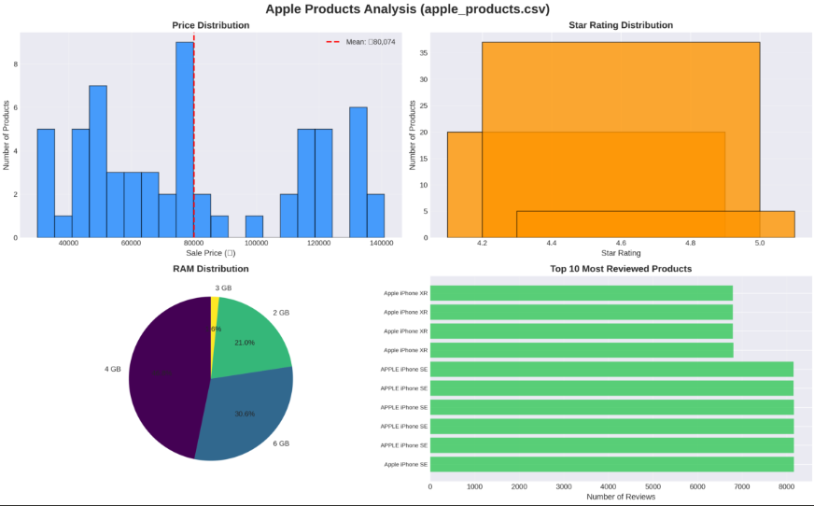

Analysis of Collected Dataset
The image above represents the exploratory analysis of Apple products data. It includes four major analytical visualizations.
Price Distribution Analysis
The histogram titled “Price Distribution” shows the distribution of Apple product prices in Indian Rupees. The x-axis represents the sale price, while the y-axis represents the number of products.
From the chart, it is observed that product prices range approximately between ₹35,000 and ₹1,40,000. The red dashed line indicates the average price, which is around ₹80,074. This suggests that most Apple products in the dataset fall within the mid to premium price range. The distribution confirms Apple’s positioning as a premium brand in the Indian market.

Data Preparation - Prepare the Data for Visualization
Flipkart Smartphone Market Analysis
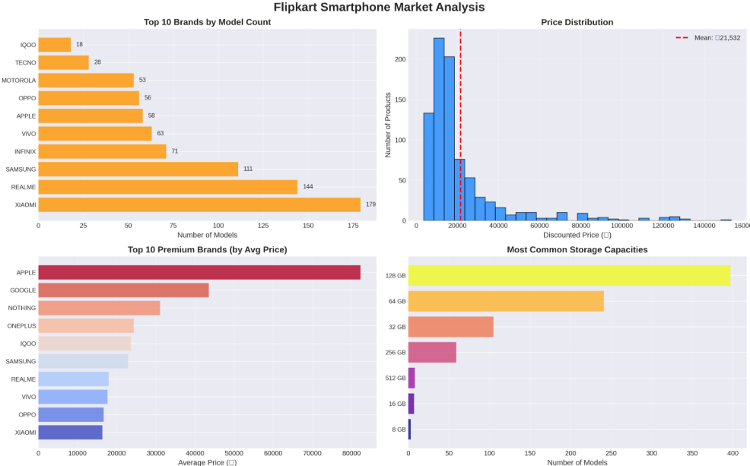

This image represents a Flipkart Smartphone Market Analysis. It shows an overall analytical view of smartphone brands, pricing patterns, and storage configurations available in the Indian market through Flipkart.
Below is a clear explanation of what the image is about.
The image contains four major analytical visualizations that study different aspects of the smartphone market.
The first chart shows the Top 10 Brands by Model Count. This horizontal bar graph displays the number of smartphone models offered by different brands. Xiaomi has the highest number of models, followed by Realme and Samsung. This indicates that these brands focus on offering a wide product range in different price segments. Apple has fewer models compared to these brands, which reflects its focused and premium product strategy.
The second chart represents the Price Distribution of smartphones. It is a histogram that shows how smartphone prices are distributed across different price ranges. The red dashed line indicates the average price, which is around ₹21,532. Most smartphones fall in the lower to mid-price range, while fewer models are available in the high-premium segment. This suggests that the Indian market is largely price-sensitive and dominated by budget and mid-range smartphones.
The third chart shows the Top 10 Premium Brands by Average Price. This graph compares brands based on their average selling price. Apple has the highest average price among all brands, clearly indicating its premium positioning in the market. Google and Nothing also appear in the higher price range, while brands like Xiaomi, Oppo, and Vivo operate mostly in affordable and mid-range segments.
The fourth chart represents the Most Common Storage Capacities available in smartphones. The analysis shows that 128 GB is the most common storage option, followed by 64 GB and 32 GB. Higher storage options such as 256 GB and 512 GB are available but less common. This indicates that consumers prefer balanced storage options that offer good value for money.
Apple Annual Revenue Analysis from 2006 to 2022
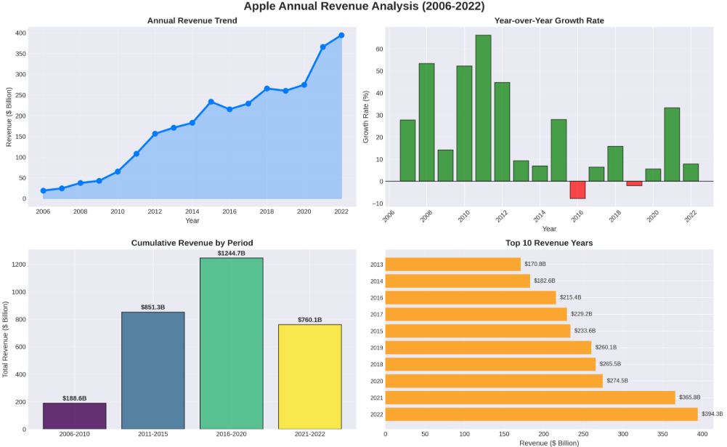
This image represents an Apple Annual Revenue Analysis from 2006 to 2022. It provides a detailed financial performance overview of Apple over a 17-year period using four different analytical visualizations.
The first chart shows the Annual Revenue Trend. This line graph illustrates Apple’s revenue growth year by year. The revenue has increased significantly from around 24 billion dollars in 2006 to nearly 394 billion dollars in 2022. The graph clearly shows steady long-term growth, with sharp increases after 2010. There are slight fluctuations in certain years, but the overall direction is strongly upward. This indicates Apple’s consistent expansion and strong global market performance.
The second chart presents the Year-over-Year Growth Rate. This bar chart shows the percentage growth in revenue compared to the previous year. Some years, such as around 2010 and 2011, show very high growth rates above 50 percent. A few years show slower growth, and there is a small negative growth period around 2016. However, after that, Apple recovered and continued growing. This visualization helps in understanding not just total revenue but also how fast the company expanded each year.
The third chart displays Cumulative Revenue by Period. The revenue is grouped into four time periods: 2006 to 2010, 2011 to 2015, 2016 to 2020, and 2021 to 2022. The highest cumulative revenue is observed during 2016 to 2020, exceeding 1200 billion dollars. This indicates that Apple experienced massive financial expansion during this period. The most recent period also shows very strong performance in a shorter time span.
The fourth chart shows the Top 10 Revenue Years. This horizontal bar chart highlights the years in which Apple generated the highest revenue. The highest revenue year is 2022, followed by 2021 and 2020. This confirms that Apple’s financial performance has been strongest in recent years, showing maturity and global dominance in the technology market.
Overall, this image provides a clear financial growth story of Apple. It shows long-term revenue expansion, periods of rapid growth, temporary slowdowns, and strong recovery. The analysis demonstrates Apple’s ability to maintain consistent growth and achieve record-breaking revenues over time.

iPhone Market Penetration Analysis from 2008 to 2022
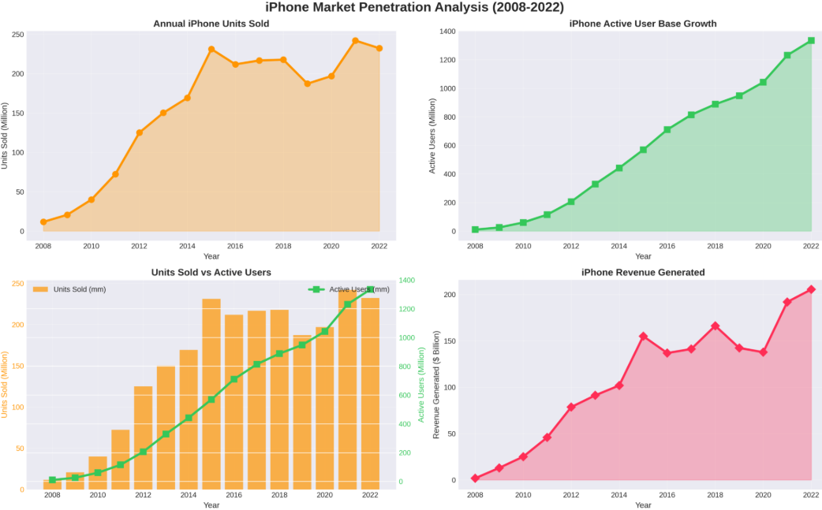

This image represents an iPhone Market Penetration Analysis from 2008 to 2022. It explains how iPhone sales, active users, and revenue have grown over time. The image contains four analytical visualizations that together show the expansion of the iPhone ecosystem.
The first chart shows the Annual iPhone Units Sold. This line graph presents the number of iPhones sold each year in millions. Sales started at a very low level in 2008 and increased rapidly until around 2015, where sales crossed 200 million units. After slight fluctuations in the middle years, sales again reached high levels around 2021 and 2022. This trend indicates strong global demand and consistent market penetration of iPhones over time.
The second chart shows the iPhone Active User Base Growth. This graph highlights the number of active iPhone users worldwide in millions. Unlike unit sales, the active user base shows continuous and steady growth every year without decline. It increases from a small number in 2008 to more than 1300 million users by 2022. This indicates strong customer retention and ecosystem loyalty, meaning users continue to stay within the Apple ecosystem.
The third chart compares Units Sold and Active Users in a combined visualization. The bar graph represents units sold, while the line graph represents active users. This comparison clearly shows that even when annual sales fluctuate, the total active user base continues to grow steadily. This proves that Apple’s long-term strategy focuses not only on selling devices but also on maintaining a strong installed user base.
The fourth chart represents iPhone Revenue Generated. This line graph shows revenue in billions of dollars generated by iPhone sales each year. Revenue increases sharply after 2012, with noticeable peaks in later years such as 2015, 2018, 2021, and 2022. This reflects both higher sales volume and premium pricing strategy. Even during periods of stable unit sales, revenue growth suggests higher average selling prices.
Overall, this image demonstrates the strong market penetration of the iPhone. It shows consistent growth in sales, a rapidly expanding active user base, and increasing revenue generation. The analysis highlights Apple’s ability to build a loyal customer ecosystem and maintain financial growth over a long period.

Country-wise iPhone Market Share Analysis
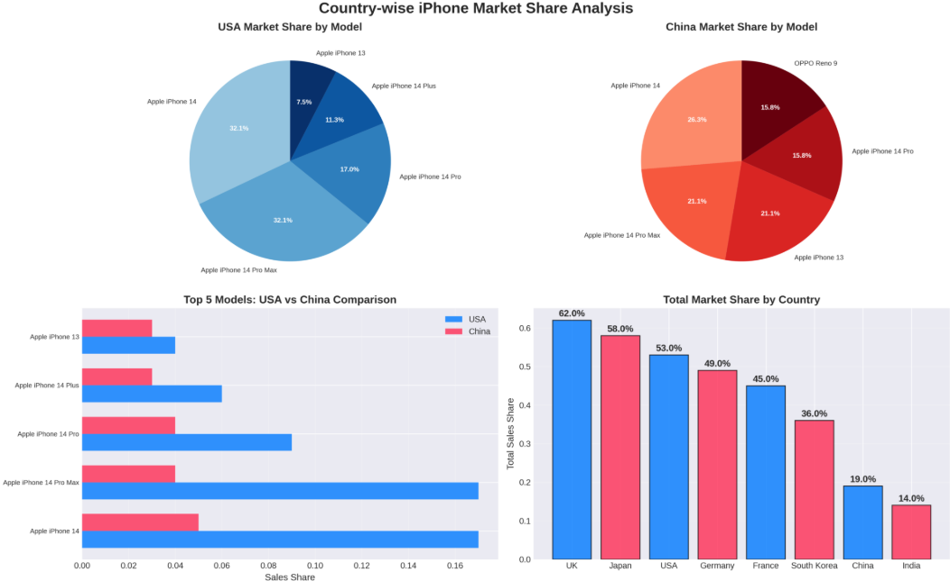
This image represents a Country-wise iPhone Market Share Analysis. It compares iPhone model performance in different countries and highlights how Apple’s market share varies across regions.
The image contains four analytical visualizations that explain market dominance and model popularity.
The first chart shows the USA Market Share by Model. This pie chart displays the percentage share of different iPhone models in the United States. iPhone 14 and iPhone 14 Pro Max hold the highest shares, each contributing around 32 percent. The iPhone 14 Pro and 14 Plus have moderate shares, while the iPhone 13 holds a smaller portion. This indicates that in the USA, newer premium models dominate sales.
The second chart shows the China Market Share by Model. This pie chart presents the distribution of iPhone models in China. The iPhone 14 holds the highest share at around 26 percent. The iPhone 14 Pro Max and iPhone 13 both contribute around 21 percent. The iPhone 14 Pro and OPPO Reno 9 each hold around 16 percent. This shows that in China, competition is stronger, and non-Apple brands like OPPO also capture a noticeable share.
The third chart compares the Top 5 Models between USA and China. This horizontal bar chart directly compares model performance in both countries. It clearly shows that premium models like iPhone 14 Pro Max and iPhone 14 perform significantly better in the USA compared to China. While China also shows strong sales, the dominance gap is smaller due to local competition.
The fourth chart represents Total Market Share by Country. This bar graph shows Apple’s overall market share percentage in different countries. The UK has the highest share at around 62 percent, followed by Japan at 58 percent and the USA at 53 percent. Germany and France show moderate shares. China and India have comparatively lower shares at 19 percent and 14 percent respectively. This indicates that Apple has stronger dominance in developed markets compared to price-sensitive markets.
Overall, this image highlights regional differences in iPhone popularity and market strength. It shows that Apple performs strongly in Western and developed countries, while facing tougher competition in Asian markets such as China and India. The analysis helps in understanding geographic performance and regional marketing strategy effectiveness.
Quarterly Smartphone Market Share Analysis from 2019 to 2022
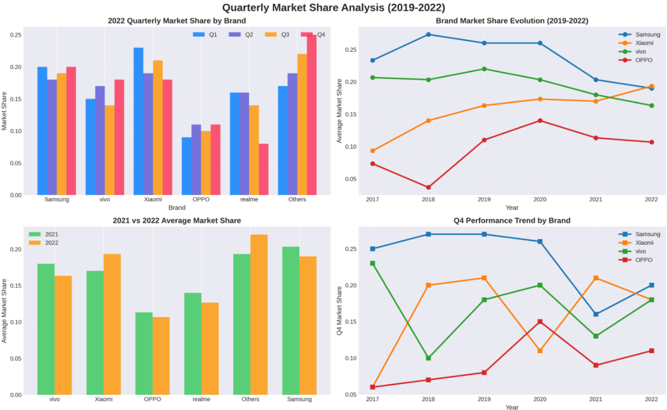
This image represents a Quarterly Smartphone Market Share Analysis from 2019 to 2022. It analyzes brand-wise performance across quarters and shows how market share evolved over time. The visualization focuses on major brands such as Samsung, Xiaomi, Vivo, OPPO, Realme, and Others.
The first chart shows the 2022 Quarterly Market Share by Brand. This bar chart compares Q1, Q2, Q3, and Q4 performance for each brand in 2022. Xiaomi and Samsung show strong competition across quarters. Xiaomi performs particularly well in Q1 and Q3, while Samsung maintains relatively stable performance. OPPO and Realme have moderate shares, while the “Others” category shows noticeable growth in Q4. This indicates seasonal demand fluctuations and competitive dynamics within the year.
The second chart presents Brand Market Share Evolution from 2019 to 2022. This line graph shows how Samsung, Xiaomi, Vivo, and OPPO performed over multiple years. Samsung had a strong market share in earlier years but shows a gradual decline by 2022. Xiaomi shows steady growth over time and nearly matches Samsung in 2022. Vivo remains relatively stable with slight fluctuations. OPPO shows moderate variation with some peaks and drops. This trend highlights increasing competition and shifting brand dominance in the smartphone market.
The third chart compares 2021 and 2022 Average Market Share. This bar graph clearly shows which brands gained or lost share between the two years. Xiaomi and Others show growth in 2022 compared to 2021. Samsung shows a slight decline. OPPO and Realme show minor changes. This indicates that Xiaomi is strengthening its position, while Samsung faces growing competition.
The fourth chart shows Q4 Performance Trend by Brand from 2017 to 2022. This line graph focuses specifically on fourth-quarter performance, which is usually a peak sales season. Samsung had strong Q4 performance in earlier years but shows a decline in 2021 before slight recovery in 2022. Xiaomi shows fluctuating but competitive Q4 results. Vivo and OPPO display moderate variations. This analysis helps understand seasonal sales patterns and brand strategies during high-demand periods.
Overall, this image provides a detailed competitive market analysis of smartphone brands over time. It highlights quarterly fluctuations, long-term market share evolution, and competitive positioning among major brands. The analysis shows increasing competition and dynamic shifts in brand leadership within the smartphone industry.
iPhone Model Market Share Analysis
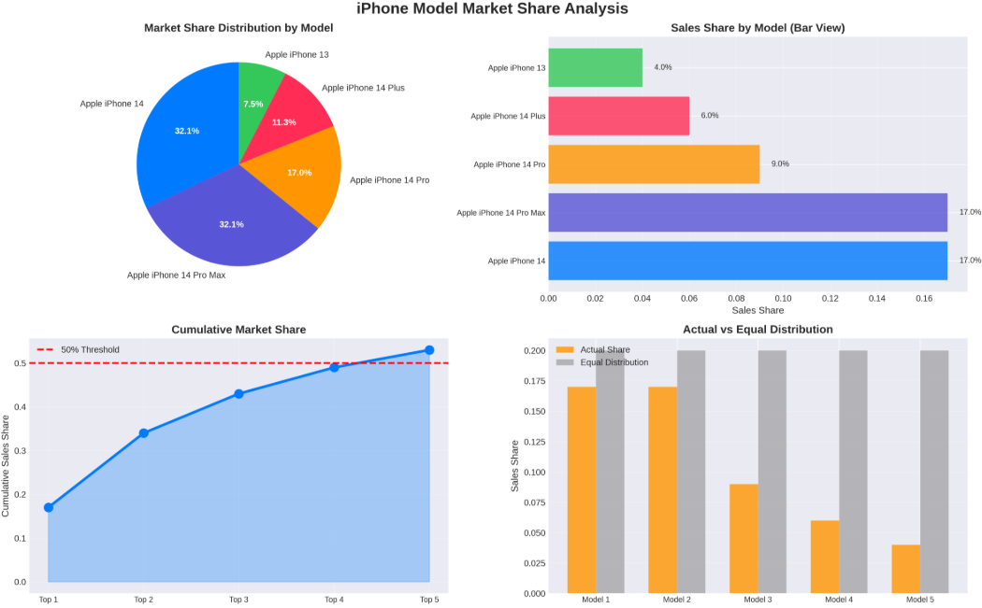

The first chart is a pie chart showing Market Share Distribution by Model. The Apple iPhone 14 and iPhone 14 Pro Max both hold the highest share at around 32.1 percent each. This means these two models are the most popular among customers. The iPhone 14 Pro has about 17 percent share, while iPhone 14 Plus has around 11.3 percent. The iPhone 13 has the smallest share at 7.5 percent. This shows that customers are strongly preferring the regular iPhone 14 and the Pro Max variant.
The second chart is a bar graph showing Sales Share by Model. It visually confirms that iPhone 14 and iPhone 14 Pro Max have the highest sales share at 17 percent each in the bar view. The iPhone 14 Pro follows with 9 percent, then iPhone 14 Plus with 6 percent, and iPhone 13 with 4 percent. This indicates that higher-end and newer models attract more buyers.
The third chart shows Cumulative Market Share. It demonstrates how the total market share increases as we add the top-selling models one by one. The first two models together cross more than 30 percent. When the top three models are combined, the cumulative share increases significantly. By the time all five models are included, the total share crosses the 50 percent threshold marked in red. This suggests that a small number of top models contribute to a large portion of total sales.
The fourth chart compares Actual vs Equal Distribution. If sales were evenly distributed, each model would have equal share. However, the actual distribution shows a clear imbalance. The top two models exceed equal distribution, while the remaining models fall below it. This highlights customer preference concentration on specific flagship models.
Overall, this image clearly shows that the iPhone 14 and iPhone 14 Pro Max dominate the market. Sales are not evenly distributed, and premium models are driving most of the revenue. It demonstrates how product positioning and consumer preference influence market share.

Data Visualization
Data visualization is the process of representing data in graphical form to make it easier to understand and analyze. It helps transform complex data into visual formats such as charts graphs and maps. The main purpose of data visualization is to simplify information so that patterns trends and outliers can be easily identified. By presenting data visually it becomes more accessible intuitive and meaningful for better decision making.
In this step, graphical representations of the prepared dataset are created using Tableau to help users understand and explore the information effectively. The main objective is to transform complex data into visual formats that are easy to interpret and analyze.
Different types of visual elements such as line charts, bar graphs, pie charts, area charts, and maps are created to represent various aspects of the data. These visualizations help in identifying patterns, trends, comparisons, and outliers clearly. For example, revenue trends can be shown using line charts, market share using pie charts, regional performance using maps, and comparisons between brands using bar charts.
Interactive features such as filters, legends, and drill-down options are applied to make the dashboard more dynamic and user friendly. This allows users to explore specific time periods, regions, or product categories based on their requirements.
In this stage of the project, multiple unique visualizations were created to analyze performance, efficiency, and market trends. The objective was to represent the dataset in different graphical formats so that comparisons, trends, distributions, and relationships between variables could be clearly understood.
Various types of visualizations were used to explore different business aspects of the dataset.
KPI Visualization
A KPI visualization was created to display key performance indicators such as total revenue, total units sold, market share percentage, or growth rate. This provides a quick summary view of the most important business metrics and helps stakeholders understand overall performance at a glance.
Model Specification Visualization
A visualization was created to represent model specifications such as RAM, storage, battery type, and pricing details. This helps in comparing product features and understanding how specifications influence market performance.
Bar Chart Showing Battery Type
A bar chart was used to analyze battery type distribution across different smartphone models. This helps in understanding which battery technologies are most commonly used and preferred in the market.
Treemap Showing Brand and Price Comparison
A treemap was created to compare brands based on their pricing segments. The size of each block represents the brand’s contribution while color variations indicate pricing levels. This helps in identifying premium and budget brand positioning.
Bubble Chart Showing Model Wise Share of iPhone
A bubble chart was used to visualize the market share of different iPhone models. The size of each bubble represents the share percentage, making it easy to identify the most dominant models.
Lined Bar Chart Showing Country Wise Best Selling Smartphone
A combined line and bar chart was created to analyze best selling smartphones across different countries. The bar portion shows model performance in each country while the line represents overall trend comparison. This helps in understanding regional preferences.
Donut Chart for Quarterly Share
A donut chart was used to represent quarterly market share distribution. This visualization clearly shows how performance varies across different quarters within a year.

Line Chart for Annual Revenue Year Wise
A line chart was created to display annual revenue growth over time. This helps in identifying revenue trends, growth patterns, and performance fluctuations year by year.
Map Showing Global Market Share
A geographical map visualization was used to show global market share distribution across countries. This helps in understanding regional dominance and identifying strong and weak markets.
Dashboard
In this stage of the project, an interactive dashboard was created using Tableau to present all important visualizations in a single organized interface. A dashboard is a graphical user interface that displays key information in a structured and easy to understand format.
The dashboard was designed specifically for analyzing iPhone market performance and related business metrics. It integrates multiple visualizations such as revenue trends, market share distribution, country wise performance, quarterly share analysis, and model wise comparison into one unified view.
Key performance indicators are displayed at the top of the dashboard to provide a quick overview of important metrics such as total revenue, total units sold, and overall market share. Supporting charts and graphs are arranged systematically so users can easily compare trends and patterns.
Interactive filters such as year, country, and model selection are added to allow users to explore the data dynamically. This enables real time analysis and helps stakeholders focus on specific regions or time periods.
The dashboard is designed to be clear, responsive, and user friendly. Its purpose is to simplify complex data and support effective decision making by presenting insights in a visual and accessible manner.

Story
In this project, a data story was created to present the analysis in a structured and meaningful narrative format. A data story helps transform raw data and visualizations into a logical sequence that explains insights clearly.
The story begins with an introduction that explains the objective of the project, which is to analyze Apple’s iPhone market performance and its impact in India. It sets the context by highlighting the importance of market trends, revenue growth, and consumer preferences.
The body of the story presents the visualizations in a systematic order. It includes KPI analysis, revenue trends, quarterly market share, country wise performance, model wise comparison, and global market distribution. Each visualization supports the narrative by explaining patterns, trends, and relationships within the dataset.
The conclusion summarizes the key findings such as top performing models, revenue growth patterns, market share dominance, and regional performance insights. It also highlights the business implications and how these insights can support data driven decision making.
The data story ensures that the audience can follow the analysis step by step and clearly understand the insights derived from the dashboard.
Responsive and Design of Dashboard
The responsiveness and design of the dashboard titled Data Driven Insights on iRevolution A Data Driven Exploration of Apple’s iPhone Impact in India were carefully planned to ensure clarity and usability.
The dashboard follows a user centered design approach. All visual elements are arranged logically so that users can easily navigate and interpret the data. Important KPIs are placed prominently at the top, followed by supporting charts and graphs.
Clear and concise information is maintained throughout the dashboard. Proper titles, labels, and legends are used to avoid confusion and improve readability.
Interactivity is an important feature of the dashboard. Filters such as year, region, and model selection allow users to dynamically explore the data. This makes the dashboard responsive to user input and supports deeper analysis.
The design is data driven and focuses only on meaningful insights. Unnecessary visual clutter is avoided to maintain a clean and professional layout.
Accessibility and customization options ensure that the dashboard can be viewed on different screen sizes and adjusted according to user needs. Basic security considerations are also maintained to protect sensitive data.
Overall, the dashboard is designed to be responsive, interactive, and insightful, enabling users to make informed business decisions effectively.
Performance testing
The process of checking how efficiently and smoothly a dashboard works when handling data. It mainly focuses on the amount of data being rendered from the database to Tableau, the impact of filters on system responsiveness, and the number of visualizations and calculated fields used. If a large volume of data is pulled without optimization, the dashboard may become slow and unresponsive. Therefore, it is important to monitor the volume of data being retrieved, remove unnecessary fields, optimize queries, and use filters properly to improve performance. The amount of data rendered depends on the dataset size and the database’s capacity to store and retrieve information efficiently. Additionally, calculated fields in Tableau allow users to create custom columns using formulas, but using too many complex calculations can increase processing time and reduce performance. Hence, performance testing ensures that the dashboard loads quickly, responds smoothly to user interactions, and provides timely and reliable insights.

Applications
This project can be applied in business analysis, market research, and strategic planning. Companies can use this type of dashboard to analyze product performance, track revenue growth, compare regional sales, and understand customer preferences. It helps marketing teams identify high performing models and regions, while management can use it for data driven decision making.

Advantages
One major advantage of this project is that it converts complex raw data into clear and interactive visual insights. It helps in identifying trends, patterns, and outliers quickly. The use of KPIs provides a quick performance overview. Interactive filters allow users to explore the data dynamically. The dashboard is user friendly and improves decision making speed and accuracy. It also saves time compared to manual data analysis.

Limitations
Although the dashboard provides valuable insights, it depends completely on the quality and accuracy of the dataset. If the data is incomplete or incorrect, the results may be misleading. Large datasets may also affect performance if not optimized properly. Additionally, the dashboard focuses only on available variables, so external market factors that are not included in the dataset cannot be analyzed.

Final Conclusion
The project Data Driven Insights on iRevolution: A Data Driven Exploration of Apple’s iPhone Impact in India successfully demonstrates how data visualization and business intelligence tools can transform raw data into meaningful insights. By using Tableau, the dataset was prepared, analyzed, and converted into interactive visualizations that clearly represent market trends, revenue growth, model performance, and regional distribution.
Through KPIs, charts, maps, and dashboard interactivity, the project provides a comprehensive understanding of iPhone market performance. The structured data story helps present insights in a logical and engaging manner, making complex information easy to interpret. Performance testing ensured that the dashboard runs efficiently and provides reliable results.
Overall, this project highlights the importance of data driven decision making in today’s competitive market. It shows how visualization techniques can support businesses in identifying trends, improving strategies, and making informed decisions effectively.

